**Project Name**: Live Cricketing Score Board

**Group Members**:

Team Leader – Pravesh maurya

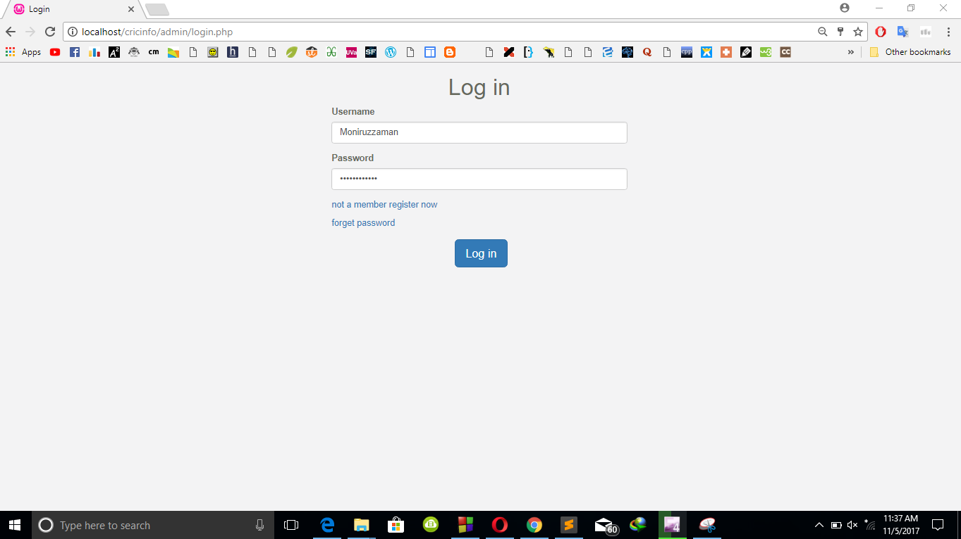

**Login:**

Here, we can login into this system from this page. It is compulsory for all the admins and also for super admin.

­­­­­

**Functionalities of Super Admin**

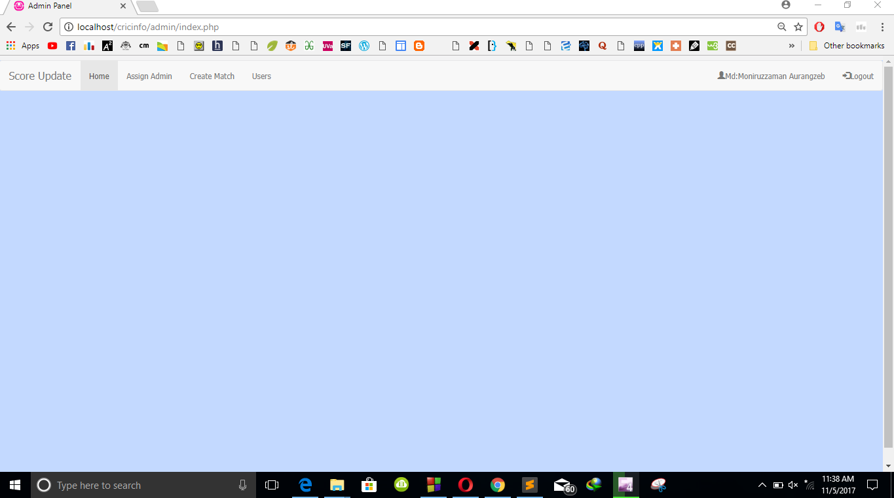

**Logged in as Super Admin:**

This is the main page for super admin. Where super admin can assign an admin into a match to control, can create a match and can approve a registered user as admin and can also remove from admin list.

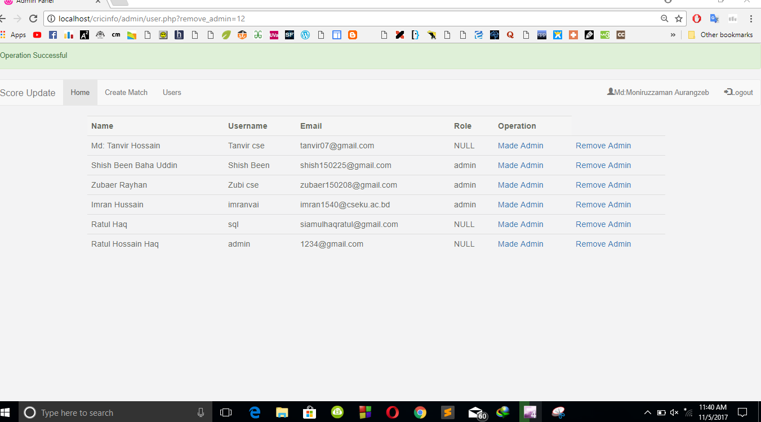

**User List:**

Here, in this page , super admin can approve a registered user as admin and also can remove an admin from the list.

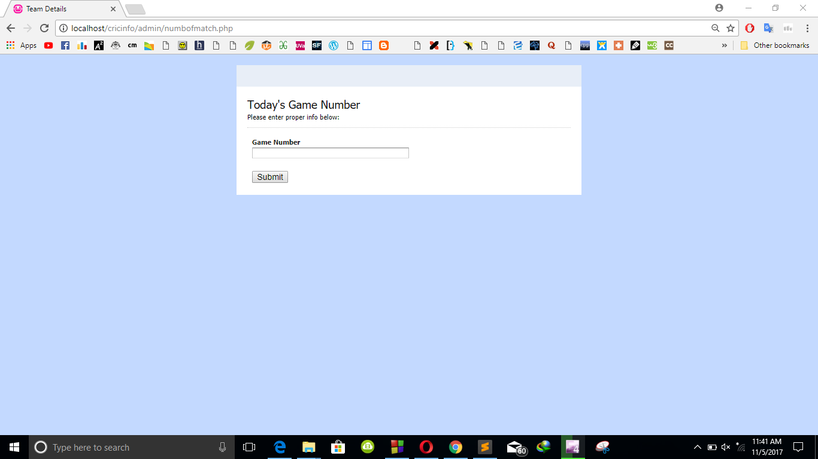

**Create Matches:**

Here, super admin defines the game number. The number of pages that will be played at a time.

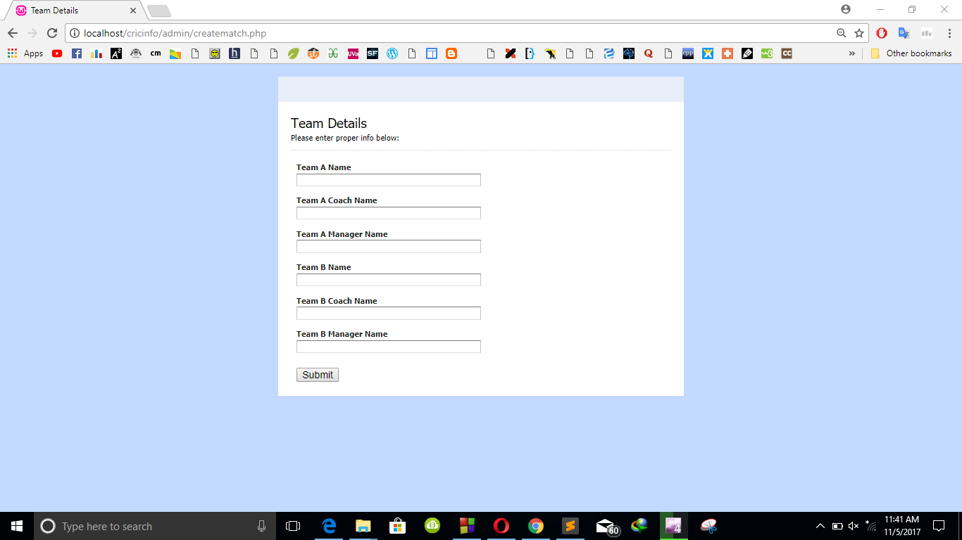

**Team Details:**

Here, admin declares the team names and some mandatory details like coach name, manager name.

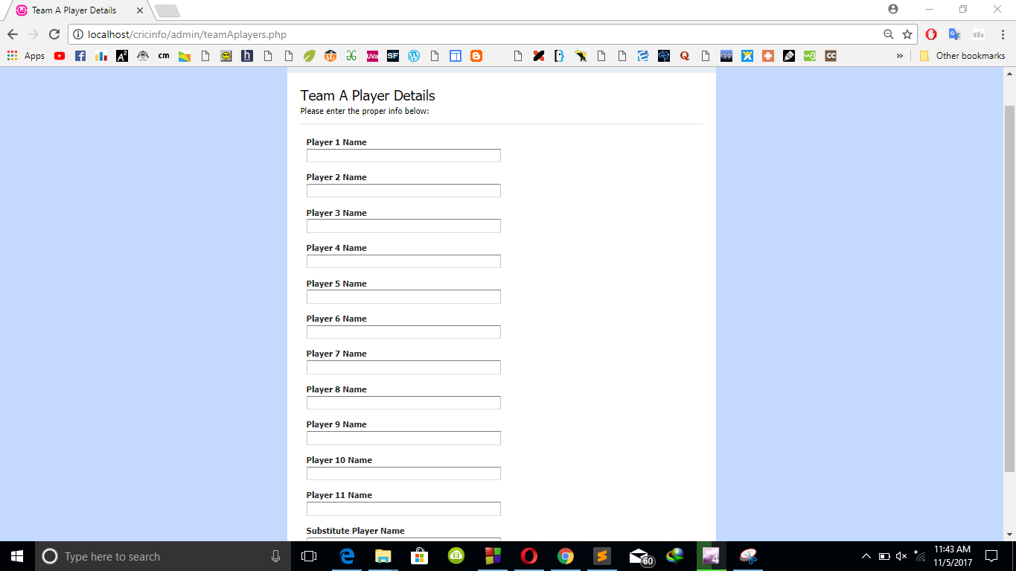

**Team A Player Details:**

Here, super admin fills the player names of first team of a match.

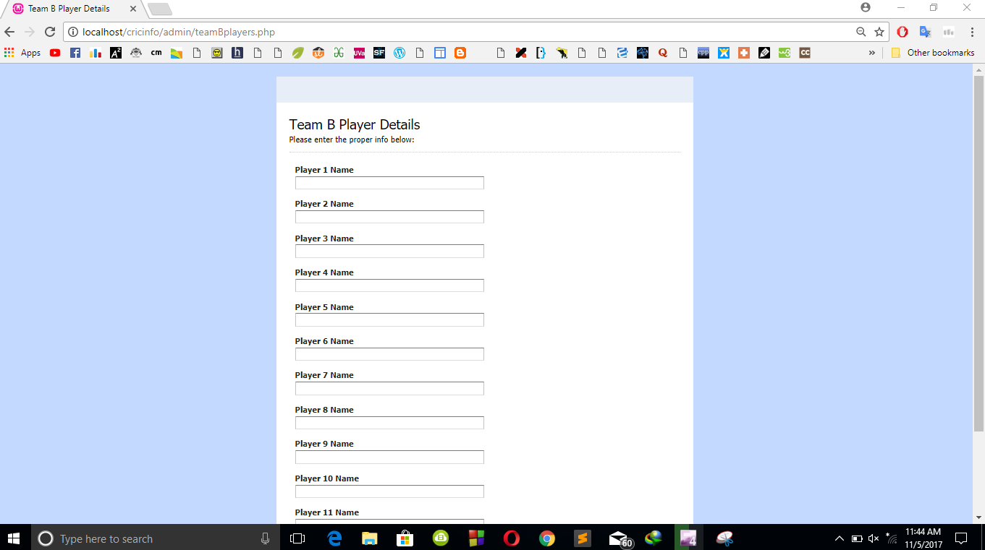

**Team B Player Details:**

Here, super admin fills the player names of second team of a match.

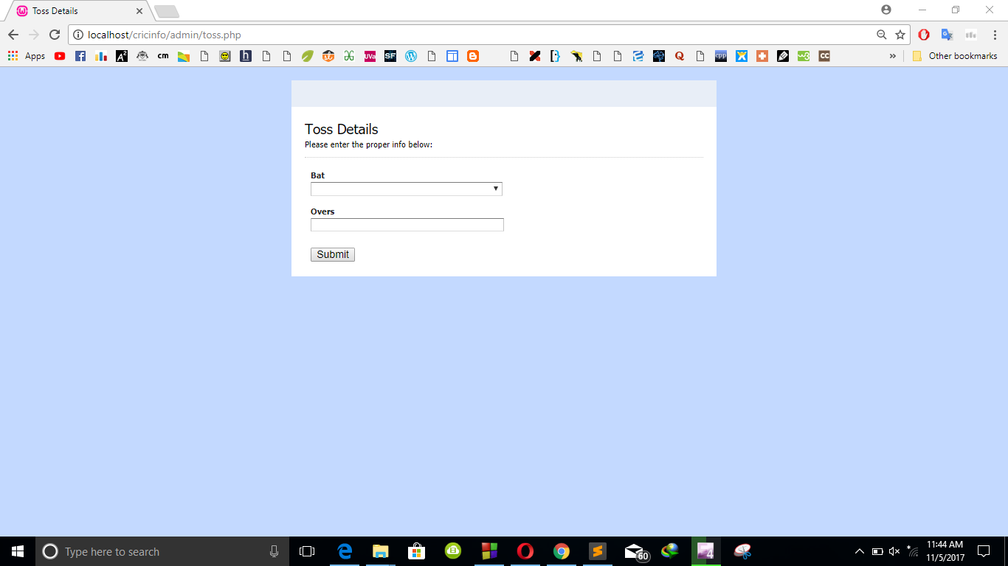

**Toss Details:**

Here super admin choose which team will bat first and the number of overs.

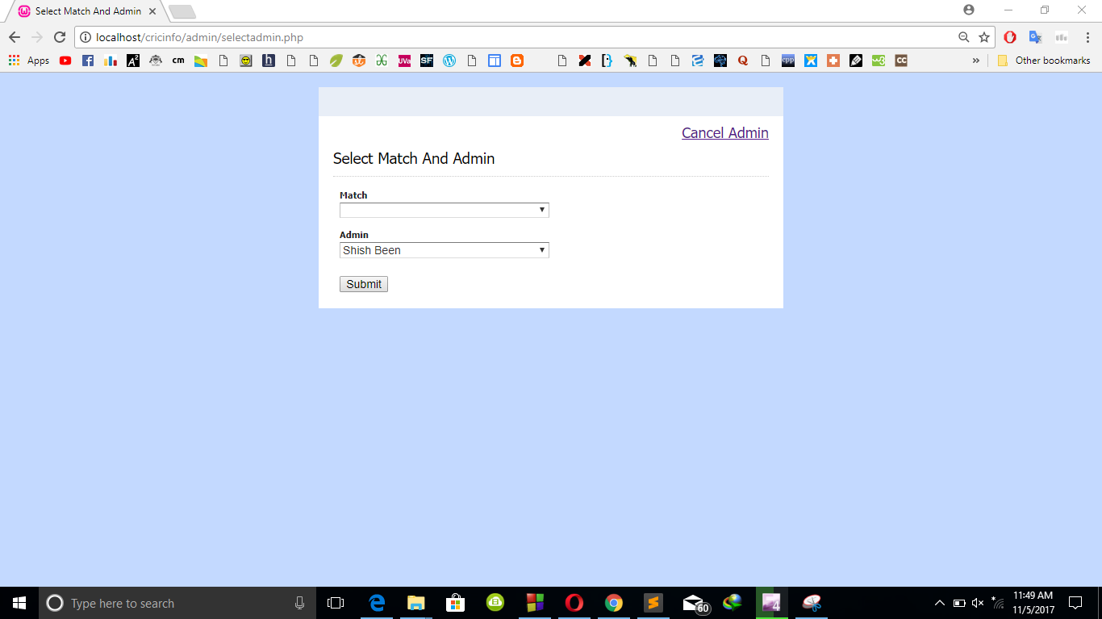

**Admin Selection:**

Here super admin will select which admin will direct any selected match.

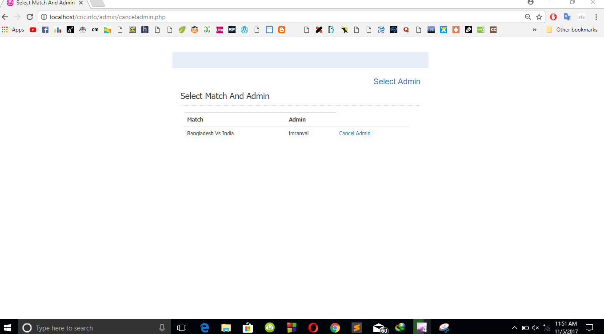

**Cancel Admin:**

Here, super admin can cancel any admin who was selected before for a match.

**Fuctionalities of a Admin**

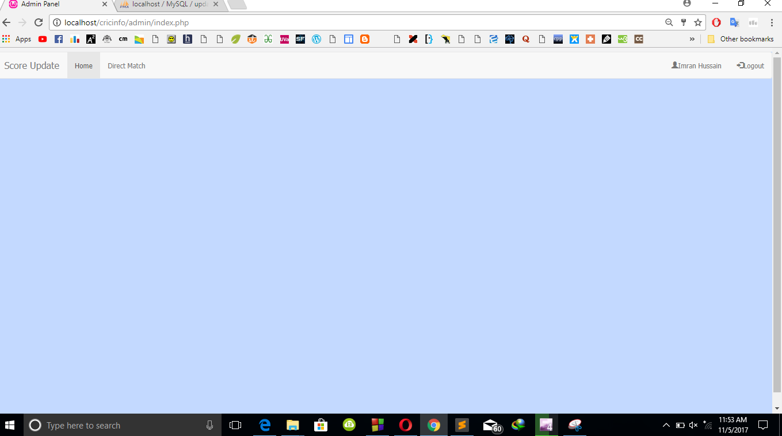

**Logged in as admin :**

This is the index page of an admin. Admin can control a match If he is selected by the super admin for it. By clicking on “Diect match” admin can do this.

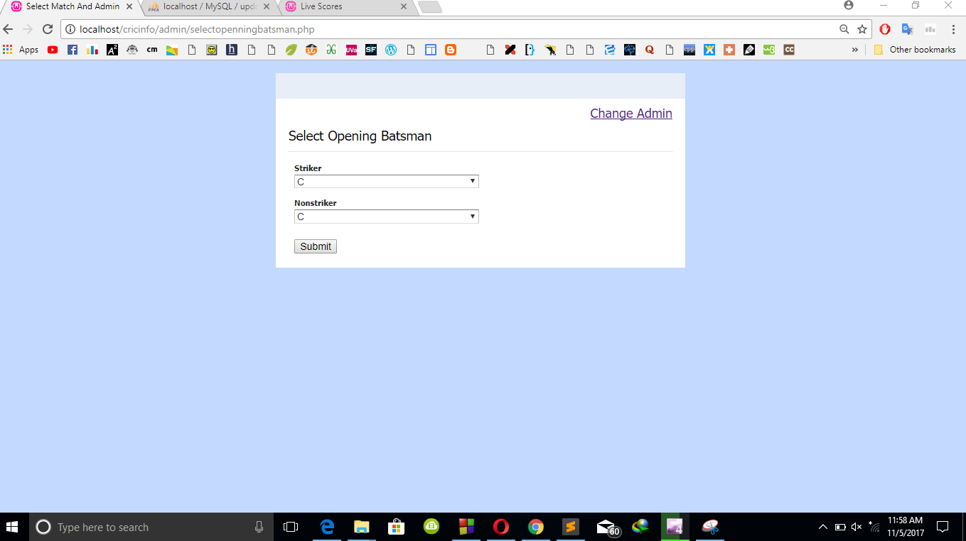

**Select opening batsman :**

Here, an admin will select the opening batsmans to start the game.

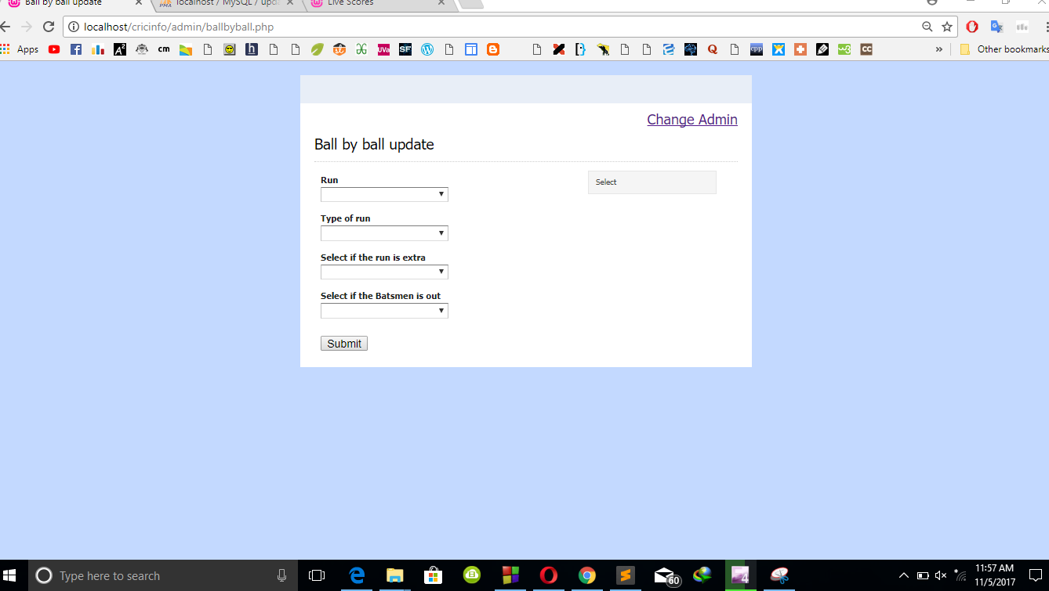

**Ball by ball update :**

Here, admin will pretend ball by ball update of the game.

**Functionalities of users**

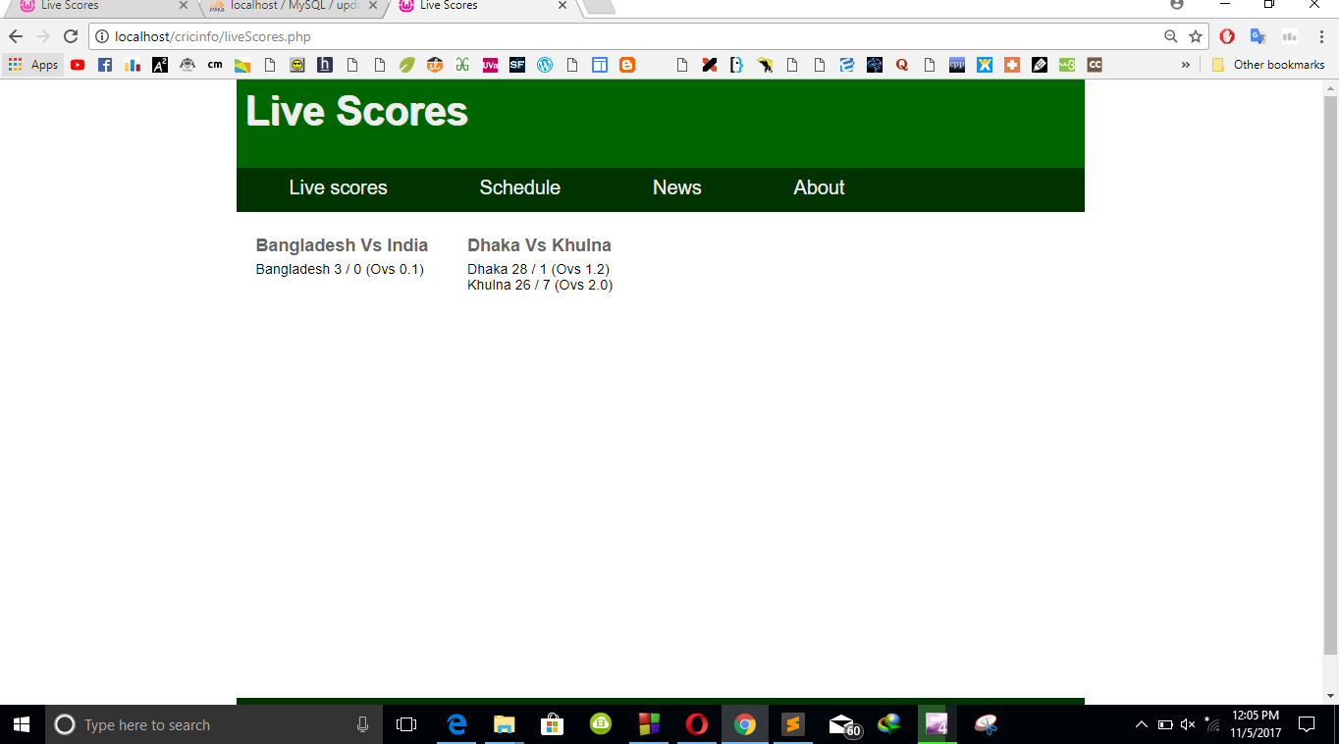

**User Interface :**

Here, users can see the result of all games shortly.

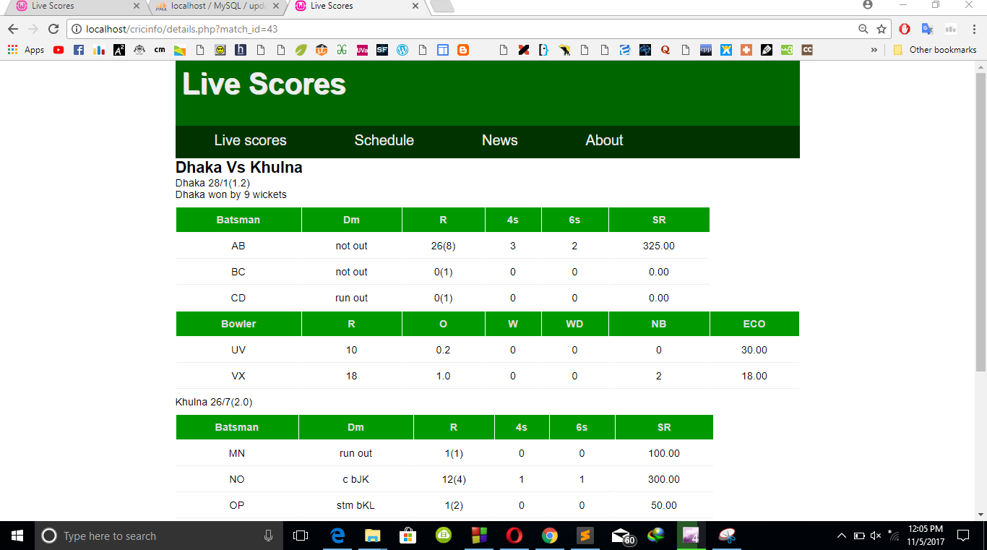

**Live Scores :**

Here, users can see a whole match details.